Jigsaw 2 Spellings

Date: W.b. 12.03.18

[](https://www.google.co.uk/url?sa=i&rct=j&q=&esrc=s&source=images&cd=&cad=rja&uact=8&ved=0ahUKEwjQ7KSv7N3VAhVC6xoKHcfQDqUQjRwIBw&url=https://www.galaxyhotchocolate.com/fund/profiles/friends-of-woodlands-pta&psig=AFQjCNEmO6qszccBwKoQ2fyc3ZZVXYwFug&ust=1503044684813499)[](http://www.google.co.uk/url?sa=i&rct=j&q=&esrc=s&source=images&cd=&cad=rja&uact=8&ved=0ahUKEwiG856H7N3VAhVJrRQKHSULDo8QjRwIBw&url=http://www.148apps.com/app/660291646/&psig=AFQjCNEmO6qszccBwKoQ2fyc3ZZVXYwFug&ust=1503044684813499)

[](http://www.google.co.uk/url?sa=i&rct=j&q=&esrc=s&source=images&cd=&cad=rja&uact=8&ved=0ahUKEwiG856H7N3VAhVJrRQKHSULDo8QjRwIBw&url=http://www.148apps.com/app/660291646/&psig=AFQjCNEmO6qszccBwKoQ2fyc3ZZVXYwFug&ust=1503044684813499)

Look Say Cover Write Check





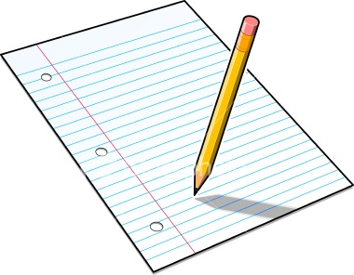



[](https://www.google.co.uk/url?sa=i&rct=j&q=&esrc=s&source=images&cd=&cad=rja&uact=8&ved=0ahUKEwieg9Xo793VAhWBGhQKHZDHBpMQjRwIBw&url=https://ux.stackexchange.com/questions/29953/speech-bubbles-meaning&psig=AFQjCNEKX-f7xmB1L2nLnIWmaHSTAIGeLA&ust=1503045674498345)

|  |  |  |  |  |
| --- | --- | --- | --- | --- |
| Spelling | Monday | Tuesday | Wednesday | Thursday |
| actual |  |  |  |  |
| centre |  |  |  |  |
| earth |  |  |  |  |
| group |  |  |  |  |
| imagine |  |  |  |  |

Please practice your spellings every day at home or at school. We will have a test each Friday morning.